Q.1




Q.2


3
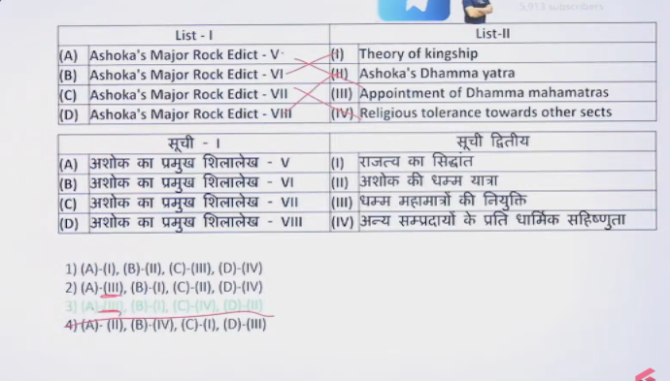

4
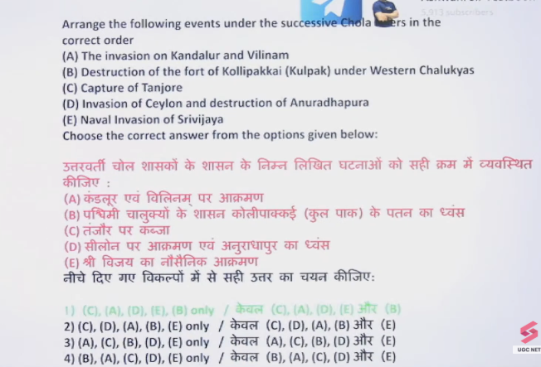
CADEB
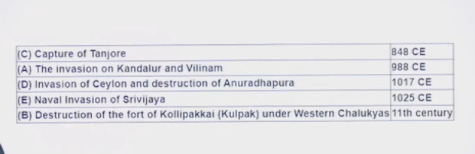
Chola Ruler

5
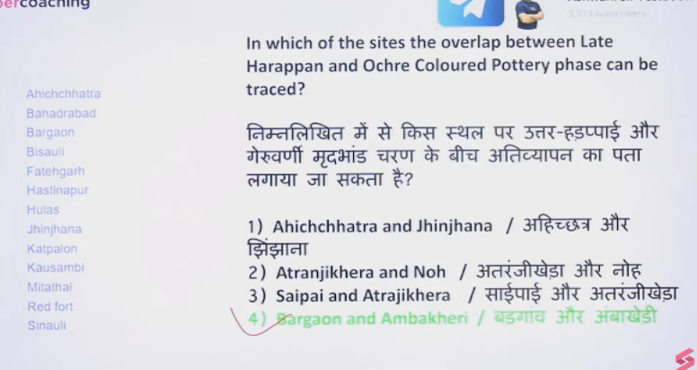

6
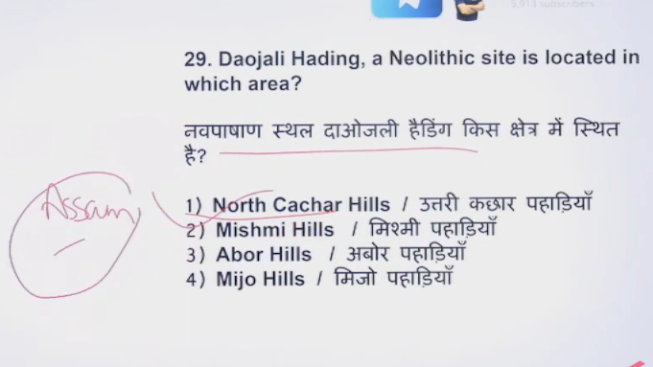

7


8




9
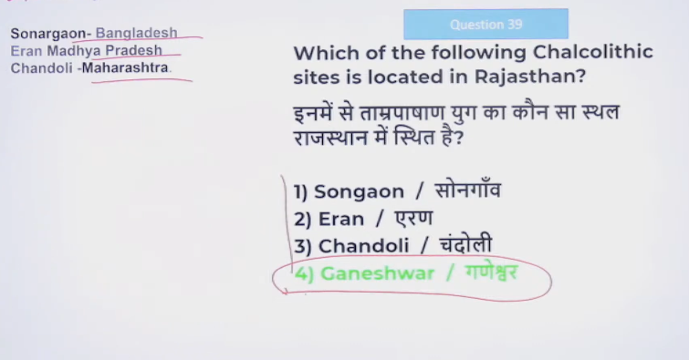

10


Q.11

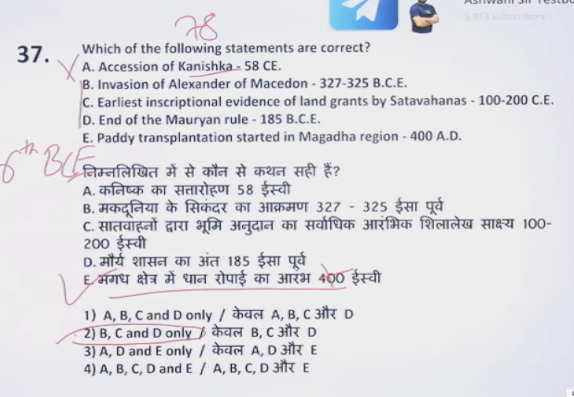

Kanishka, the most prominent Kushan emperor, ascended the throne in 78 CE, marking the start of the Shaka Era and a period of significant expansion and cultural flourishing. His accession solidified the Kushan Dynasty, with a vast empire stretching from Pakistan and Afghanistan to Northern India, setting its capital at Purushapura (modern Peshawar).
Kanishka, the most prominent Kushan emperor, ascended the throne in 78 CE, marking the start of the Shaka Era and a period of significant expansion and cultural flourishing. His accession solidified the Kushan Dynasty, with a vast empire stretching from Pakistan and Afghanistan to Northern India, setting its capital at Purushapura (modern Peshawar).
Paddy transplantation began in ancient India around the 6th century BCE, particularly in the Magadha region of the Ganga Valley. This shift to wet rice cultivation dramatically increased agricultural production and supported the rise of the Mahajanapadas, although early rice cultivation (via other methods) was present as early as 7000 BCE in sites like Lahuradewa.

12
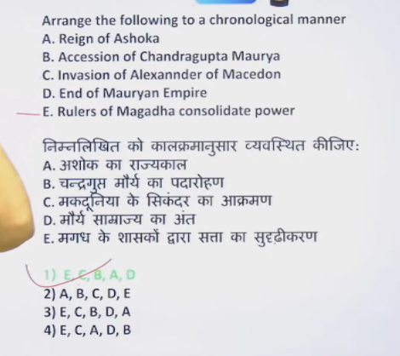

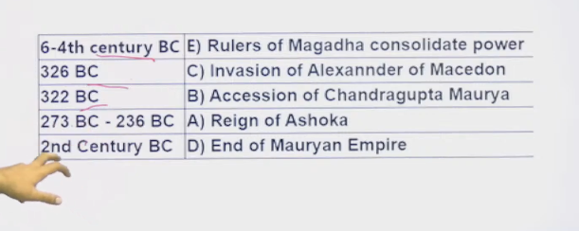

Ashoka ascended the Mauryan throne around 273–272 BCE following the death of his father, Bindusara, but his formal coronation (abhisheka) was delayed until 269–268 BCE due to a brutal war of succession, where he allegedly defeated his brothers. Supported by ministers, he secured power before undertaking the Kalinga War (c. 261 BCE).

